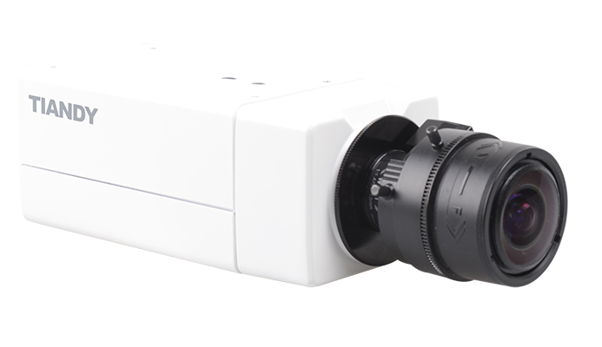

#### Features

• Up to 1920X1080 High Resolution  
• Full HD 1080P Video  
• NIR, WDR, 3D DNR, HLC  
• Triple Streams  
• Tripwire Detection  
• Perimeter Detection  
• Defog  
• TVS 6000V, Lightning/Surge 2000V Protection  
• Ultra Low Illumination: 0.002lux@(F1.2,AGC ON)  
• USB Extension

Specification

|  |  |
| --- | --- |
| Camera | |
| Image Sensor | 2MP, 1/2.8″ Sony ExmorCMOS |
| Core Processor | ARM9 Architecture |
| Operating System | Embedded LINUX |
| Signal System | PAL/NTSC |
| Mini. Illumination | Color 0.002 Lux @(F1.2, AGC ON) B/W 0.0002Lux @(F1.2, AGC ON) |
| Shutter Time | 1S～1/100000S |
| Lens Interface Type | C/CS |
| Day& Night | IR Cut Filter With Auto Switch |
| Wide Dynamic Range | 120 dB |
| Digital Noise Reduction | 3D DNR |
| Compression Standard | |
| Video Compression | H.264/MJPEG |
| Bit Rate | 32K~8Mbps |
| Audio Compression | G.711/G.726/ADPCM |
| Bit Rate | 8K~48Kbps |
| Image | |
| Max. Image Resolution | 1920×1080 |
| Frame Rate | 50Hz: 25fps (1920 × 1080), 25fps (1280 × 720) |
| 60Hz: 30fps (1920 × 1080), 30fps (1280 × 720) |
| Triple Stream | Mainstream:1080P(1920*1080) |
| Substream:D1(704*576) |
| 3rd stream:CIF(352*288) |
| Image Settings | Brightness, Saturation, Contrast,Flip Mode Adjustable by  Client Software or Web Browser |
| HLC | Y |
| Smart Defog | Y |
| Corridor | Y |
| EIS | Y |
| ROI | 4 zones |
| Privacy Mask | 4 zones |
| Picture Overlay | 200 × 200, BMP 24bit, Zone Configurable |
| Network | |
| Browser | IE 7+, Chrome 18 +, Firefox 5.0 + |
| Network Storage | NAS |
| Video Analytics | Tripwire/Perimeter |
| Alarm Trigger | Motion Detection/IP Conflict/MAC Conflict/Port Alarm |
| Protocols | TCP/IP/ICMP/HTTP/HTTPS/FTP/DHCP/DNS/DDNS/RTP/  RTSP/RTCP/PPPoE/NTP/UPnP/SMTP/SNMP/IGMP/802.1X/  QoS/IPv6/Bonjour |
| User Permission | 4 Level/8 users |
| System Compatibility | ONVIF (Profile S, Profile G),  SDK |
| Interface | |
| Audio Input | 1-ch |
| Audio Output | 1-ch |
| Communication Interface | 1-ch RJ45 10M / 100M Ethernet Interface ,RS485 |
| Alarm Input | 1-ch |
| Alarm Output | N/A |
| Video Output | 1Vp-p Composite Output（75Ω/BNC） |
| On-board Storage | Built-in Micro SD/SDHC/SDXC Card Slot, up to 64 GB |
| Extension | N/A |
| General | |
| Operating Conditions | -35℃～65℃,  0～95% RHG |
| Power Supply | DC 12V±10%/AC24V±10%/PoE |
| Power Consumption | DC12V: 5W AC24V: 7.5W |
| Circuit Protection | TVS 6000V, Lightning/Surge 2000V |
| Dimensions | 145mm×71mm×58mm |
| Weight | 600g (IP Camera Only); 800g (With Packing Box) |

Dimension

